Warrant Article I – Operating Budget
The proposed Gross Budget for the 2023-24 school year is $56,106,282. That includes all costs associated with running the district: staffing, curriculum and programs, and facility related costs.
It includes $2.287 million for costs associated with various Federal and state programs, such as special education and child nutrition. Note that these costs are directly offset by federal/state revenues.
The Gross Budget also includes funding of the various District Trust Funds. These are subject to separate voting (Warrant Articles 2 through 7) and are not shown below.
 | Current  FY22-23 | Proposed  FY23-24 | Proposed  Increase | Default  FY23-24
Operating Budget | $53,101,036 | $53, 819,282 | $718,246 1.35% | $52,457,674
Federal Programs | $2,287,000 | $2,287,000 |  | $2,287,000
Trust Funds | $1,000,000 | WA 2-7 |  | WA 2-7
Gross Budget | $56,388,036 | $56,106,282 |  | $54,744,674

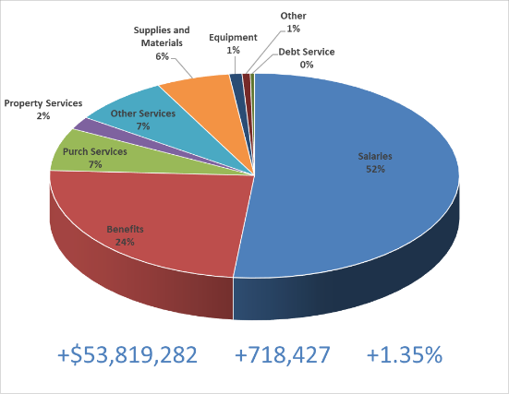
The size of the “Operating Budget” determines levels of staffing, the curriculum and programs we can offer our students, all supplies and materials, and the costs to operate and maintain District facilities and equipment.
The proposed Operating budget is well scrubbed - it is only 1.35% higher than our current budget. Given the current high inflation environment, this is remarkable. Included are the salary and benefit cost increases associated with the second year of the collective bargaining agreement approved by voters last March. There are significant increases in electric, heat, and fuel and transportation costs as well.
If the proposed budget fails to pass, the District operating budget will be determined by the prescribed “default” calculation. That will require significant cuts in staffing, programs, and facilities in comparison to both the current and the proposed operating budgets.
 | Default FY23-24 | Proposed FY23-24 | Current FY22-23
Operating Budget $ | $52,457,674 | $53,819,282 | $53,101,036
Required Cuts |  | -$1,361,608 | -$643,362

The School Board has posted additional information explaining the budgets in greater detail and has posted then on the following website: https://schoolboard.convalsd.net/budget/
The Board will also host a Community Forum on March 6, 2023 that will be focused on the proposed budget. You are encouraged to attend either in person (CVHS Lucy Hurlin Theater 6:00 PM) or online.

